Case Study – Healthcare Monitoring System
Software-Based Patient Health Monitoring Simulation
Using Python and Google Colab

1. Aim
To develop and simulate a software-based Healthcare Monitoring System in Google Colab that monitors patient temperature, heart rate, and blood oxygen saturation (SpO2), identifies abnormal readings, and generates a final patient monitoring report.
2. Objectives
• To simulate health parameters for multiple patients using Python.
• To monitor temperature, heart rate, and SpO2 values.
• To define simple threshold conditions for identifying emergency conditions.
• To display the current patient's readings and status during simulation.
• To visualize health parameters using bar charts.
• To store the final monitoring data in a Pandas DataFrame and CSV file.
3. Software Required
Software / Library | Purpose | Environment
Google Colab | Cloud-based Python execution | Web browser
Python 3 | Patient simulation and monitoring logic | Google Colab
Random | Generation of sample vital signs | Python standard library
Pandas | Data storage, tabulation, and CSV generation | Python library
Matplotlib | Visualization of health parameters | Python library
IPython.display | Clearing previous cycle output | Google Colab
Time | Delay between patient simulations | Python standard library

4. Problem Statement
Continuous monitoring of patient vital signs is important for identifying potentially abnormal conditions. In a software-only IoE healthcare scenario, a monitoring application can receive or simulate vital-sign readings, compare them against predefined thresholds, and generate an alert status. This experiment demonstrates that concept without requiring physical sensors or medical hardware.

5. System Overview
The system simulates ten patients one after another. For each patient, temperature is generated between 35.5°C and 40.5°C, heart rate between 55 and 130 BPM, and SpO2 between 88% and 100%. The system classifies a patient as EMERGENCY when temperature is above 38°C, heart rate is above 110 BPM, or SpO2 is below 92%. Otherwise, the status is NORMAL. All readings are stored and later exported as a CSV report.

6. System Architecture
Layer | Component | Function
Patient Layer | Patient 1–Patient 10 | Represents monitored individuals
Data Generation Layer | Random Vital-Sign Generator | Generates sample temperature, heart rate, and SpO2
Monitoring Layer | Threshold Checker | Compares readings with defined limits
Alert Layer | NORMAL / EMERGENCY | Classifies the current patient's condition
Visualization Layer | Matplotlib | Displays the three monitored parameters
Storage Layer | Pandas DataFrame / CSV | Stores the final monitoring report

7. Monitoring Parameters and Thresholds
Parameter | Simulated Range | Emergency Condition | Unit
Temperature | 35.5–40.5 | > 38 | °C
Heart Rate | 55–130 | > 110 | BPM
SpO2 | 88–100 | < 92 | %
The thresholds used here are simulation rules supplied by the program. They are intended for demonstrating software logic and are not a substitute for clinical assessment or medical decision-making.

8. Methodology
• Initialize ten patient names and three empty data lists.
• Generate one set of vital signs for each patient.
• Append each generated value to its corresponding list.
• Apply the emergency rule to the three readings.
• Display the current patient information in Google Colab.
• Plot temperature, heart rate, and SpO2 as three bar charts.
• Repeat the process for all ten patients.
• Create a final Pandas DataFrame containing all readings.
• Export the DataFrame to Healthcare_Report.csv.

9.Procedure
1. Start.
2. Initialize the patient list.
3. Initialize temperature_data, heart_data, and spo2_data.
4. For each patient, generate temperature, heart rate, and SpO2.
5. Store the generated values.
6. Evaluate the emergency condition.
7. Display the patient's readings and status.
8. Plot temperature, heart rate, and SpO2.
9. Wait for two seconds.
10. Repeat until all ten patients are processed.
11. Create the final report DataFrame.
12. Save the report as a CSV file.
13. Stop.

10. Python Program
# ===========================================
# Case Study : Healthcare Monitoring System
# Google Colab Simulation
# ===========================================

import random
import time
import pandas as pd
import matplotlib.pyplot as plt
from IPython.display import clear_output

# -------------------------
# Patient Names
# -------------------------

patients = [
"Patient 1","Patient 2","Patient 3","Patient 4","Patient 5",
"Patient 6","Patient 7","Patient 8","Patient 9","Patient 10"
]

temperature_data=[]
heart_data=[]
spo2_data=[]

# -------------------------
# Simulation
# -------------------------

for patient in patients:

temp=round(random.uniform(35.5,40.5),1)
heart=random.randint(55,130)
spo2=random.randint(88,100)

temperature_data.append(temp)
heart_data.append(heart)
spo2_data.append(spo2)

if temp>38 or heart>110 or spo2<92:
status="EMERGENCY"
color="red"
else:
status="NORMAL"
color="green"

clear_output(wait=True)

print("="*60)
print("HEALTHCARE MONITORING SYSTEM")
print("="*60)
print("Patient :",patient)
print("Temperature :",temp,"°C")
print("Heart Rate :",heart,"BPM")
print("SpO2 :",spo2,"%")
print("Status :",status)

plt.figure(figsize=(12,4))

# Temperature
plt.subplot(1,3,1)
plt.bar(["Temp"],[temp],color="orange")
plt.ylim(30,45)
plt.title("Temperature")

# Heart Rate
plt.subplot(1,3,2)
plt.bar(["Heart"],[heart],color="blue")
plt.ylim(40,150)
plt.title("Heart Rate")

# SpO2
plt.subplot(1,3,3)
plt.bar(["SpO2"],[spo2],color=color)
plt.ylim(80,100)
plt.title("SpO2")

plt.tight_layout()
plt.show()

time.sleep(2)

# -------------------------
# Final Report
# -------------------------

report=pd.DataFrame({

"Patient":patients,
"Temperature":temperature_data,
"Heart Rate":heart_data,
"SpO2":spo2_data

})

print("\nFINAL REPORT\n")
print(report)

report.to_csv("Healthcare_Report.csv",index=False)

print("\nCSV File Saved Successfully")
11. Simulation Output
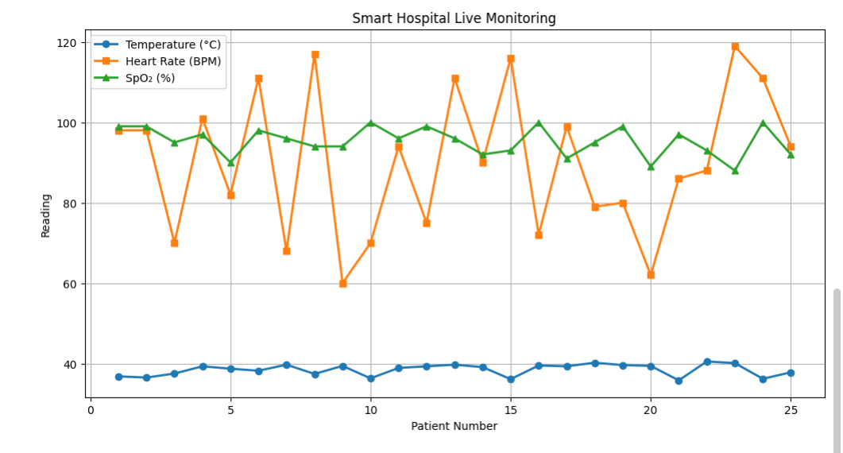

12. Result
The Healthcare Monitoring System was successfully simulated using Python in Google Colab. Temperature, heart rate, and SpO2 values were generated for ten patients, compared with predefined simulation thresholds, and classified as NORMAL or EMERGENCY. The final readings were organized in a Pandas DataFrame and saved as Healthcare_Report.csv.
emergency conditions, displays the current readings, and creates a final report. The experiment provides a foundation for developing a hardware-connected and cloud-enabled healthcare monitoring solution.

